Leisure Team Member Apprentice
Starting Salary £12,699
(18-month initial contract)

You need to be:
- Enthusiastic, Positive and Motivated
- Looking to build a career in the leisure industry
- Ability to work in a team
- Flexible, willing, and happy to work shifts including evenings, weekends, and bank holidays
- A confident swimmer (be able to swim 4 lengths comfortably)

In return we offer on-going in-house training and an opportunity to work in different areas including poolside, reception, swim teaching, holiday activities and hospitality.

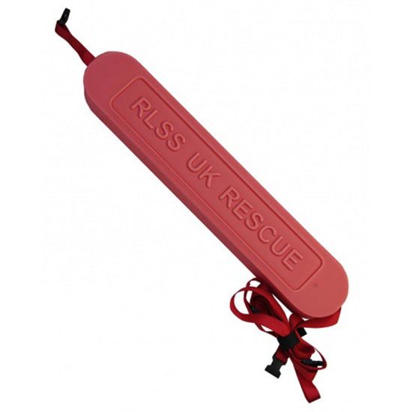
You will also gain 5 leisure industry qualifications including:

- NVQ Level 2 in Leisure Operations
- National Pool Lifeguard Qualification
- Level 2 Fitness Instructor
- STA Swim Teacher Award (L1) and Certificate (L2)
- First Aid at Work

Closing Date: 4th December 2022

To apply, download the application form from www.oxleysc.com/careers
and return to Holly Mabey on h.mabey@sherborne.com

Bradford Road. Sherborne. Dorset. DT9 3DA. Telephone 01935 818270. Email osc_info@sherborne.com

